VUMO MDHLULI
ST110521534
WEDE5020 POE2

GITHUB LINK: https://github.com/vum13/Mdhluli_ST10521534_WEDE5020_POE.git

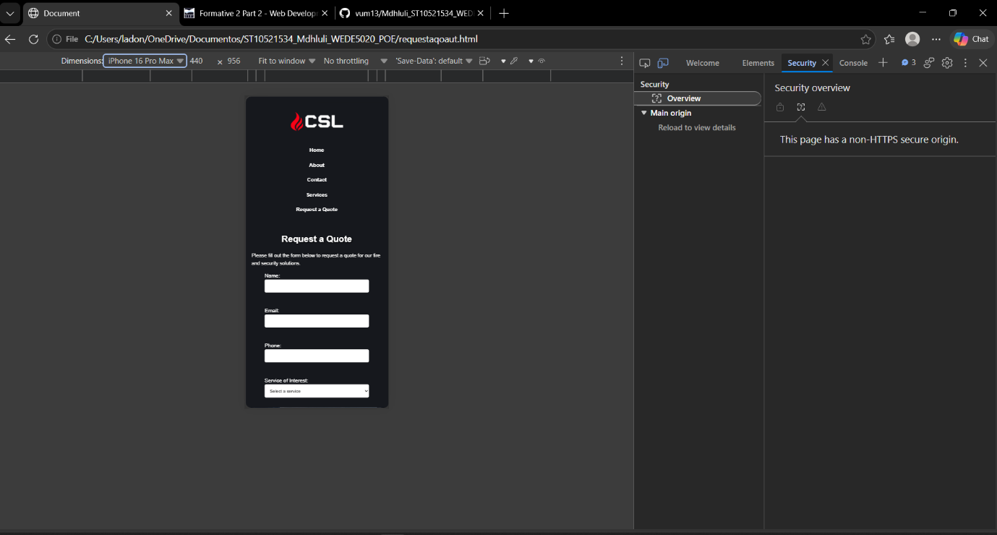
Figure 1iPhon16promax screenshot

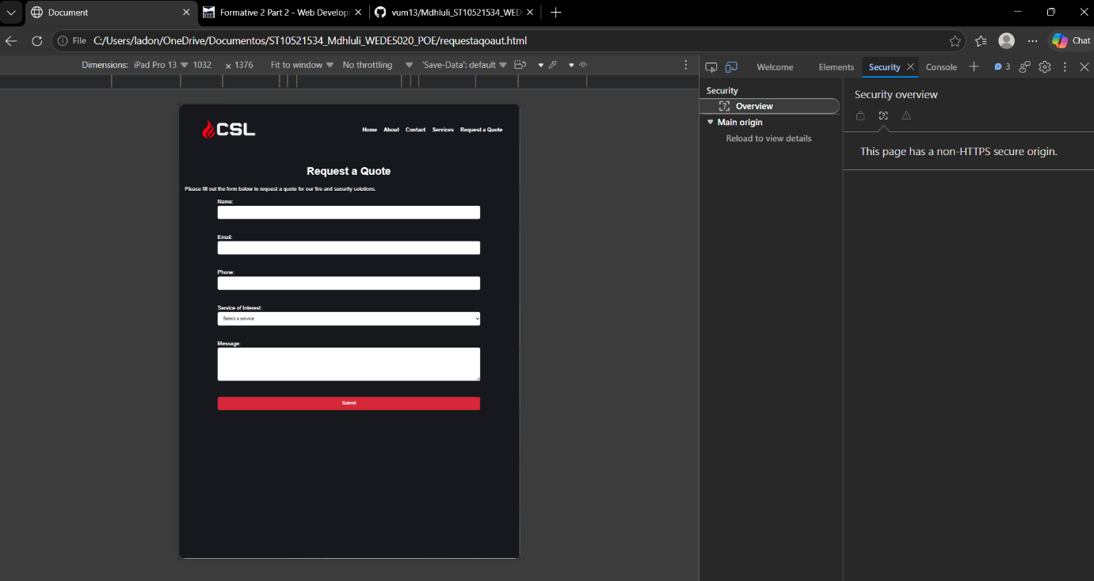
Figure 2iPad 13 screenshot

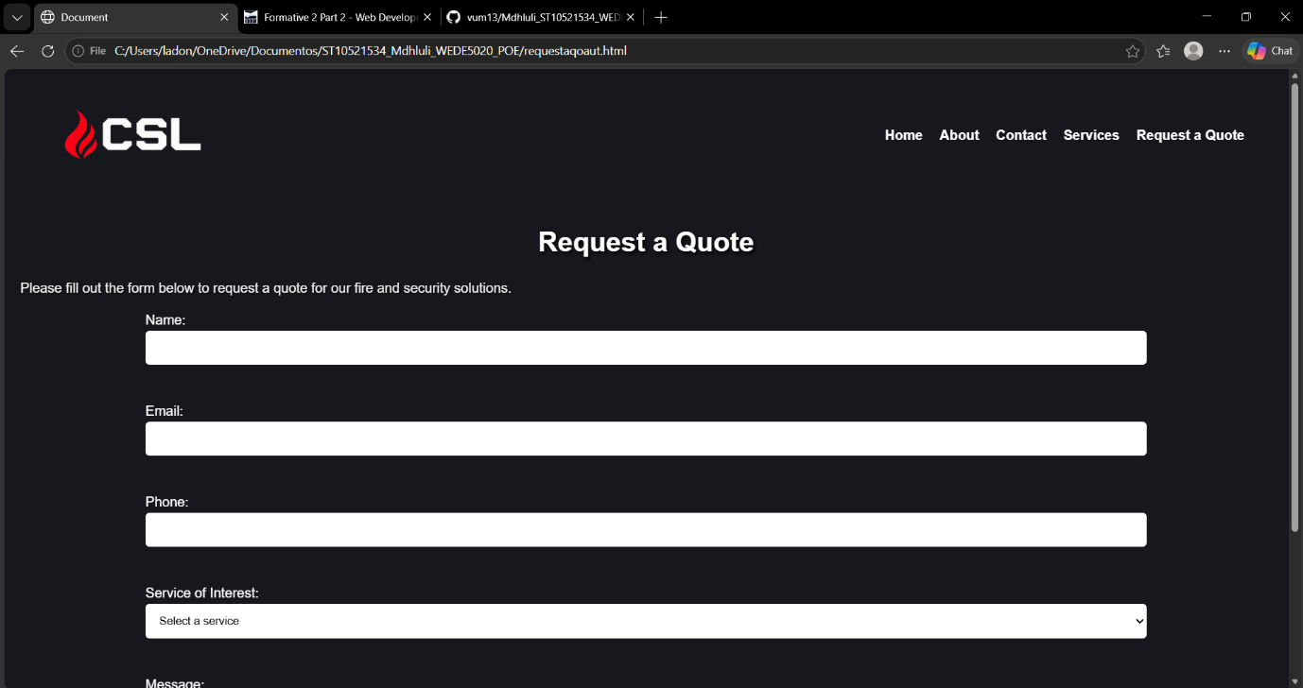
Figure 3 Desktop screenshot

